**Report**

1. PsuedoCode/Flow Chart for each method:
2. Bisection Method :

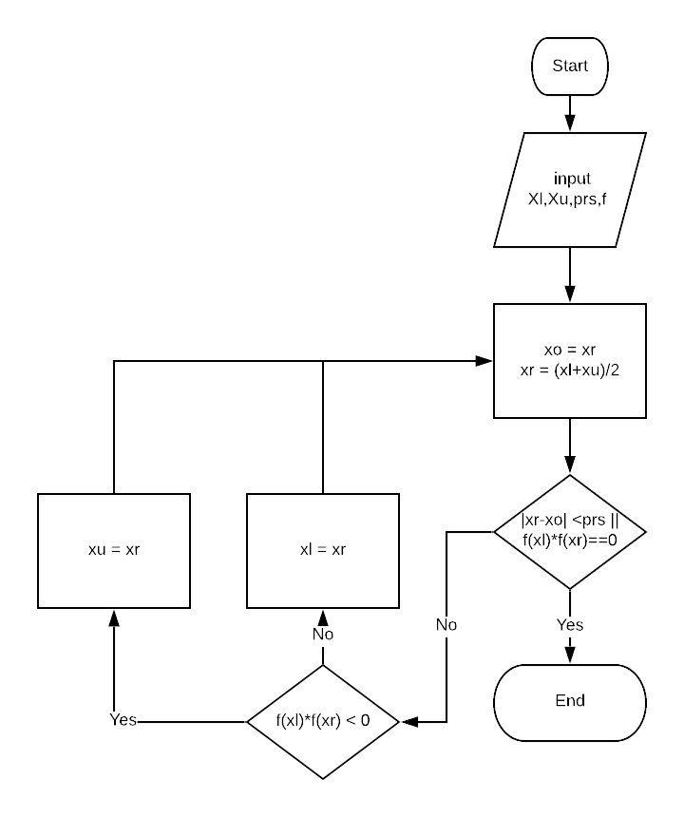

1. False-position method :

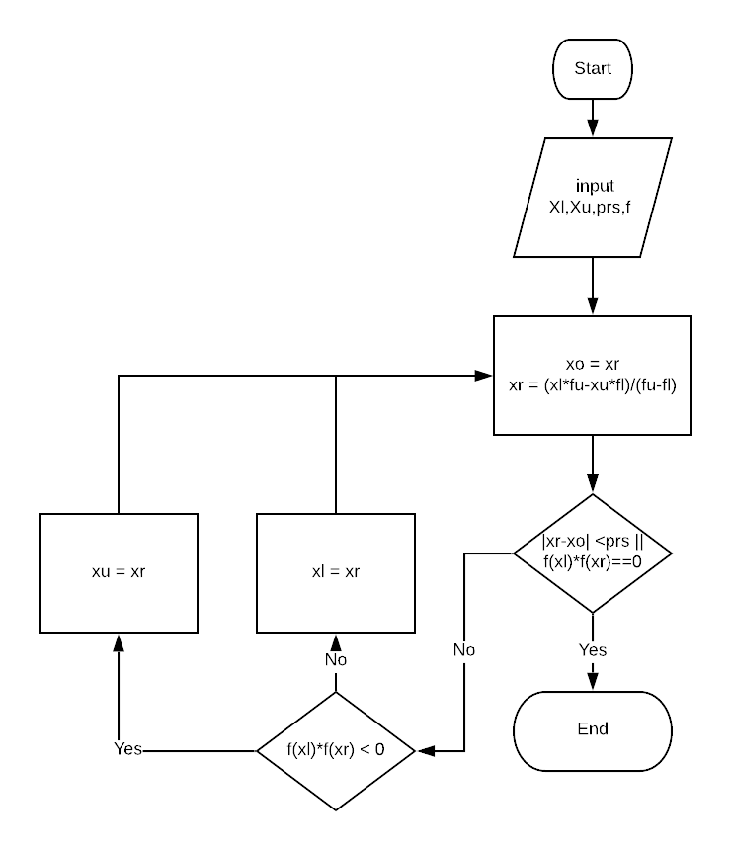

1. 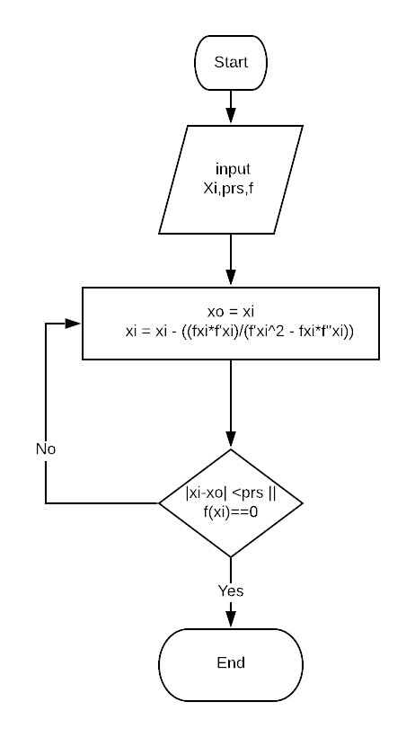Newton-Raphson method :
2. Secant Method :

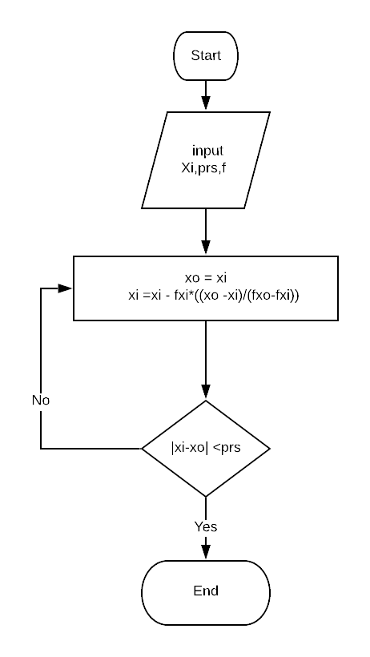

*My general Algorithm is bisection method.

*it takes more time to find root but it will always converge if there’s a root between X-upper and X-lower

1. **Data Structure Used :**

5*#iterations matrix :to save results and preview it in gui table

1. **Analysis of different methods :**
2. X4 - 18 * X2 +45 , Xupper = 3 , Xlower = 1
3. Bisection Properties :

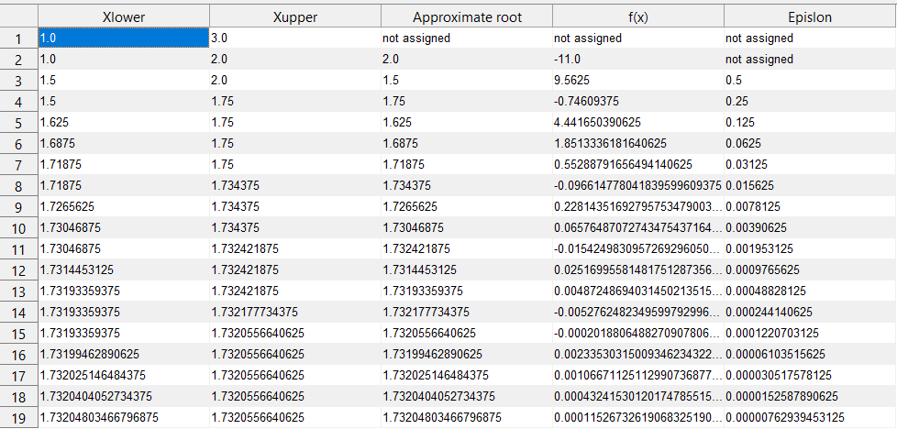

No of Itr : 18 , Execution Time : 0.88309 s

Approximate root : 1.732048  
Absolute Error : 0.0000076

1. 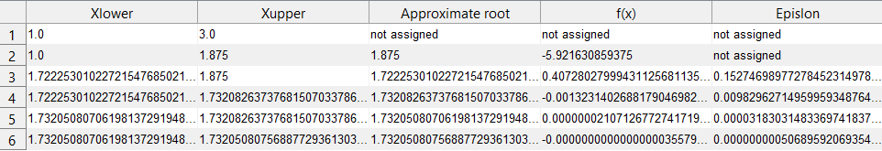False-position :

No of Itr : 5 , Execution Time : 0.406s

Approximate root : 1.732050   
Absolute Error : 0.0000000005

1. Newton-Raphson :

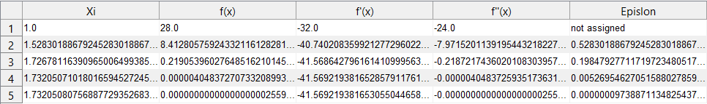

No of Itr : 5 , Execution Time : 0.417s

Approximate root : 1.732050   
Absolute Error : 0.00000009

1. Secant :

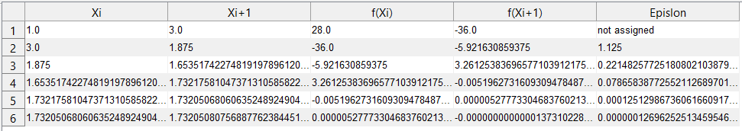

No of Itr : 6 , Execution Time : 0.355s

Approximate root : 1.732050   
Absolute Error : 0. 00000012

1. X3 – X2 -1 : Xupper = 1 , Xlower =3
2. Bisection Properties :

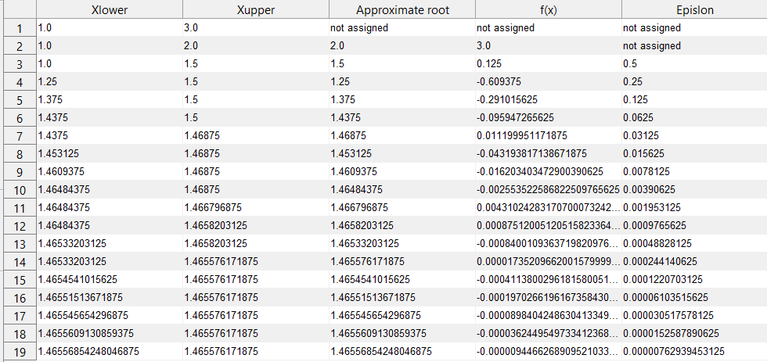

No of Itr : 18 , Execution Time : 0.936688 s

Approximate root : 1.46556  
Absolute Error : 0.0000076

1. 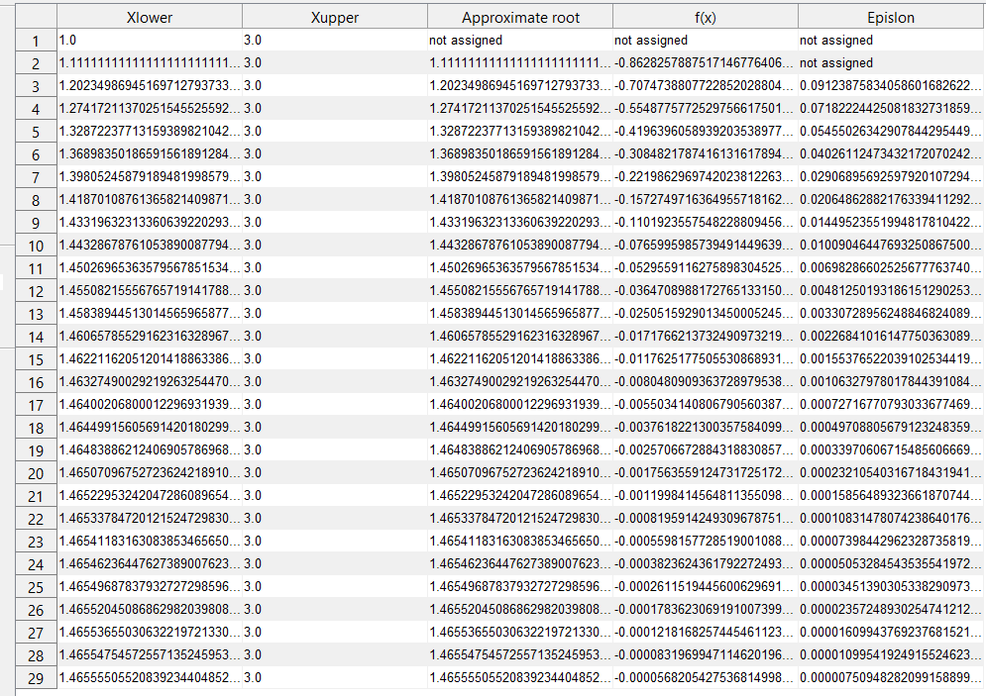false-position :

No of Itr : 28 , Execution Time : 1.3827s

Approximate root : 1.465555

Absolute Error : 0. 0.0000075

1. Newton-Raphson :

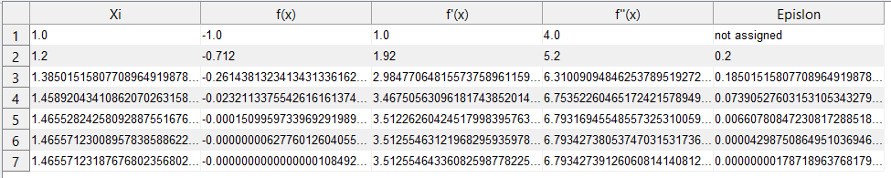

No of Itr : 6 , Execution Time : 0.444s

Approximate root : 1.46557  
Absolute Error : 0.0000000017

1. Secant :

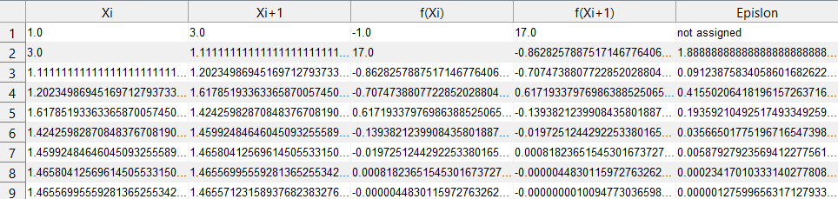

No of Itr : 8 , Execution Time : 0.515648s

Approximate root : 1.465557

Absolute Error : 0. 0000012

1. X2 –X -1 : Xupper = 1 , Xlower =3
2. Bisection Properties :

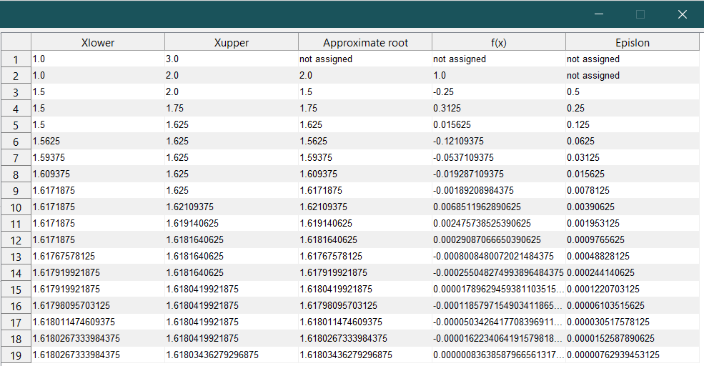

No of Itr : 18 , Execution Time : 0.852 s

Approximate root : 1.61802  
Absolute Error : 0.0000076

1. false-position :

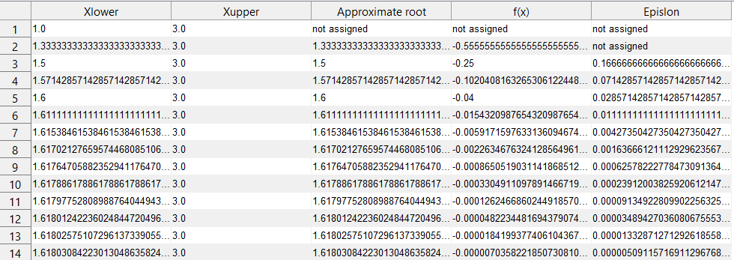

No of Itr : 13 , Execution Time : 0.677239

Approximate root : 1.61803

Absolute Error : 0. 0.00000509

1. Newton-Raphson :

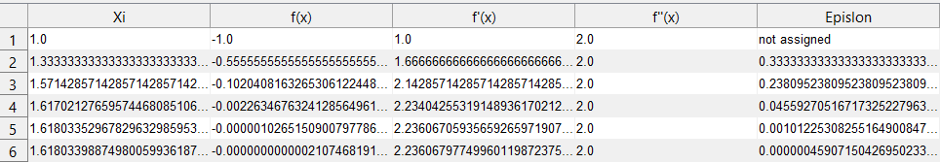

No of Itr : 5 , Execution Time : 0.45935s

Approximate root : 1.61803  
Absolute Error : 0.000000459

1. Secant :

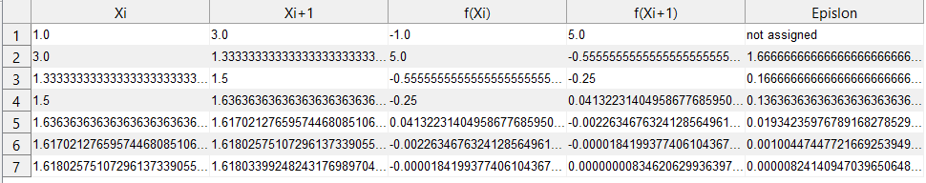

No of Itr : 6 , Execution Time : 0.391s

Approximate root : 1.61802

Absolute Error : 0. 000000824

1. **Problematic functions :**
2. X1/3:

Will diverge in case of newton-raphson method ,because the tangent line is vertical.

But will converge normally in case of secant or bisection

1. X-1 :

Won’t converge with any function,and will result in “division with zero” using any function as there’s no solution for the function on any interval.

1. **Sample Run :**
2. 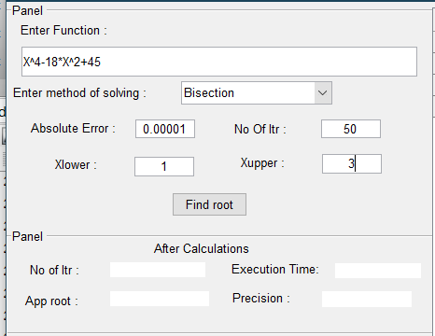**before** pressing Find root button :
3. **after**  pressing Find root button :

